**Project Design Phase - II Data Flow**

**Design and User Stories**

|  |  |
| --- | --- |
| Date | 07 NOVEMBER 2022 |
| Team ID | PNT2022TMID25347 |
| Project Name | Project - Machine Learning Based Vehicle Performance Analyzer |
| Maximum Marks | 4 Marks |

**Data Flow Diagram:**

Data flow diagrams are used to graphically represent the flow of data in a business information system. A Data flow diagram [also known as DFD] describes the processes that are part of a system for transferring data from input to file storage and reports generation.

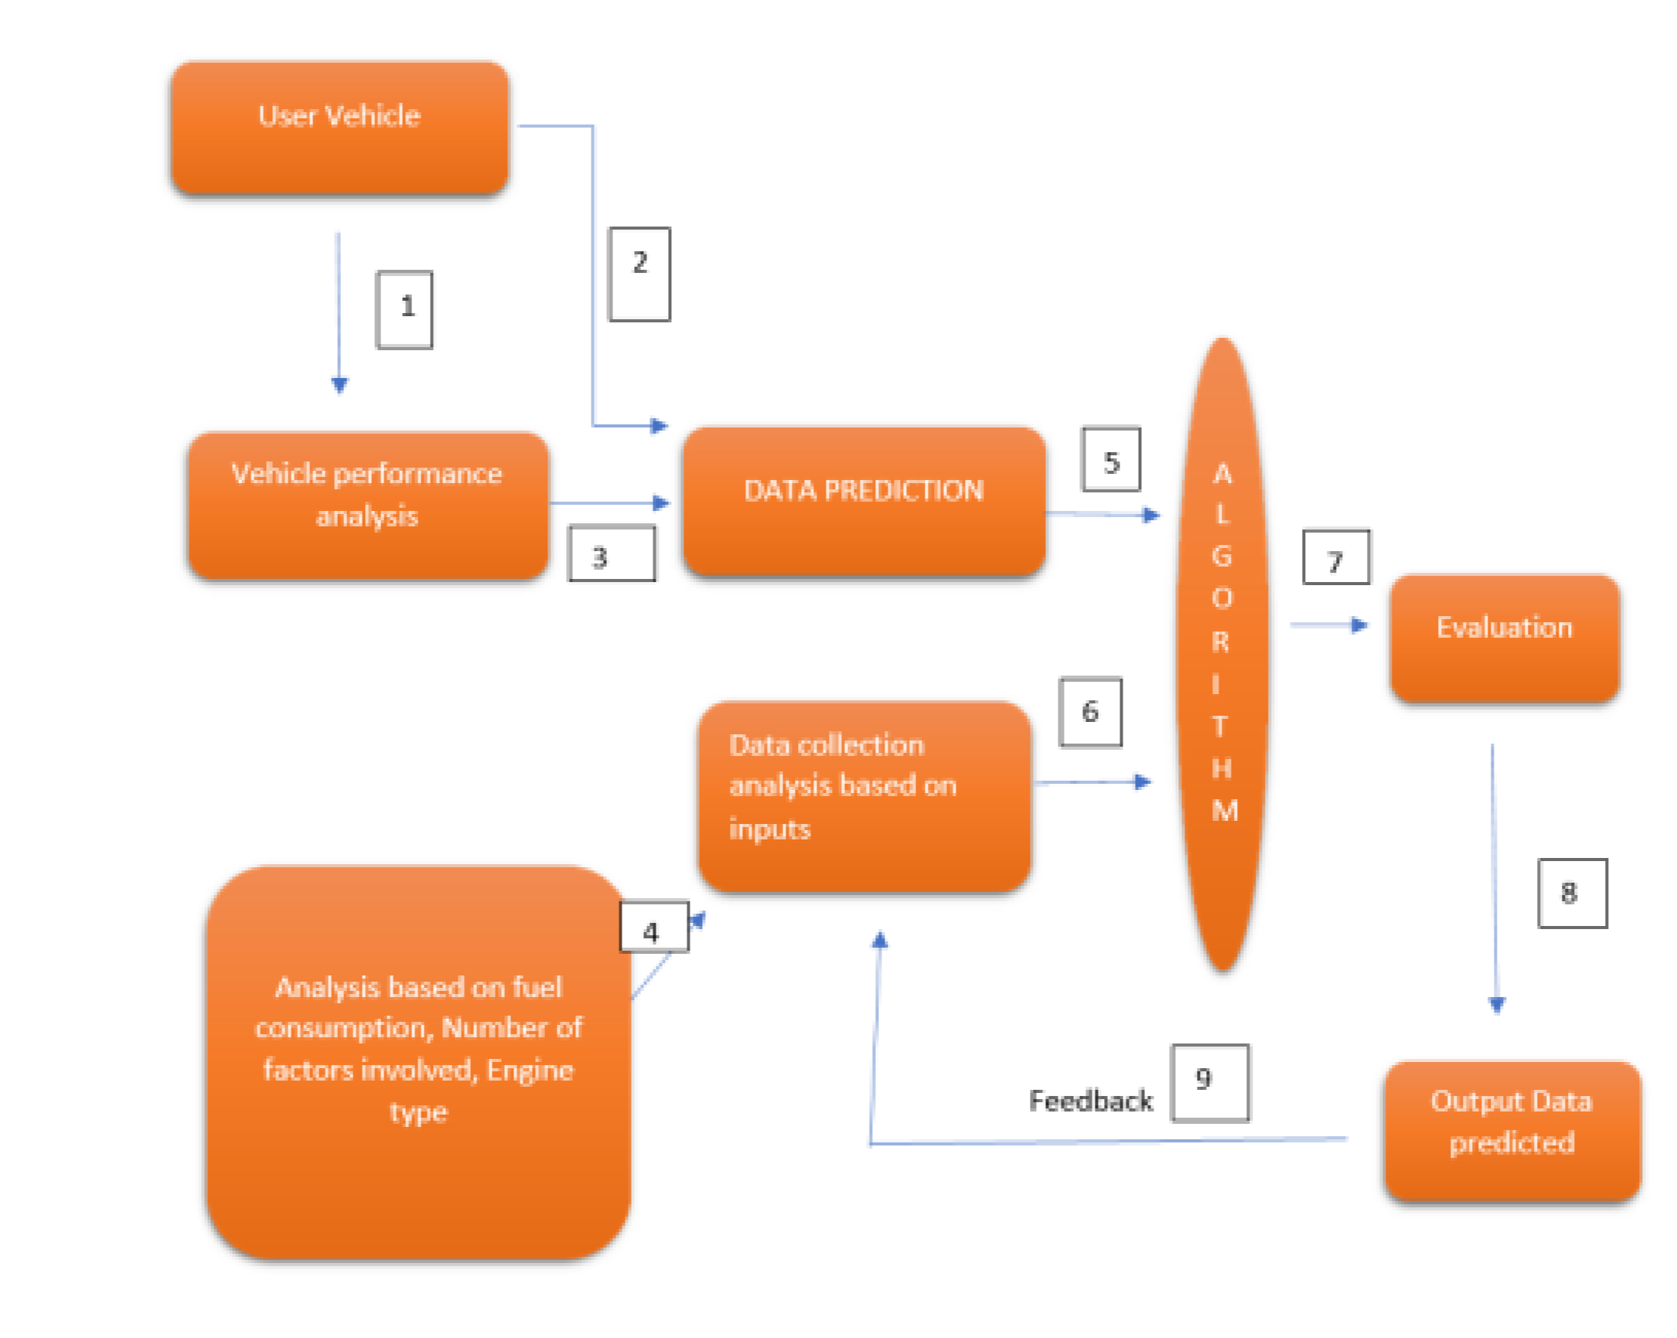

**User Stories**

Use the below template to list all the user stories for the product.

|  |  |  |  |  |  |  |
| --- | --- | --- | --- | --- | --- | --- |
| **User Type** | **Functional**  **Requirement (Epic)** | **User**  **Story**  **Number** | **User Story / Task** | **Acceptance criteria** | **Priority** | **Release** |
| Customer (Mobile user) | Registration | USN-1 | As a user, I can register for the application by entering my email address, password, and password confirmation. | I can log in to my account or dashboard. | High | Sprint-1 |
|  |  | USN-2 | As a user, I will receive an email confirming my registration for the application. | I can receive a confirmation email and click the  confirm button. | High | Sprint-1 |
|  |  | USN-3 | As a user, I can sign up for the application using Gmail. | I can sign up and gain access by using Gmail verification. | Medium | Sprint-1 |
|  | Login | USN-4 | As a user, I can access the application by entering my email address and password. | I can simply register by entering my email address and password. | High | Sprint-1 |
|  | Dashboard | USN-5 | As a user, I can access the application and view the dashboard. | I can log in and access the dashboard with  the necessary resources. | Medium | Sprint -1 |
| Customer (Web user) | Login and Dashboard | USN-7 | As a Web user, I can log in and access all of the dashboard settings. | I can login and review all of the dashboard settings. | High | Sprint-2 |
| Customer Care  Executive | Login and Dashboard | CCE-1 | As a CCE, I can access the app and see if there are any issues that need to be addressed. | I can log in and check all of the user's credentials and basic queries. | Medium | Sprint-3 |
| Administrat or | Login and Dashboard | A-1 | As Administrator, I can log in and review company policies. | I can maintain and check the status by logging in with my private Login Id and password. | High | Sprint-4 |